**User guide:**

**A. User interface pages**

**Header menu:**

This section is the same on all user interface pages; from here users can easily jump into any categories at any time or return to the homepage by clicking on the name of the elements in the menu which they are interested in.

***Figure – 1***

*(Users move to List ecard page by hovering on* ***Category*** *and clicking on* ***Birthday, Wedding, New Year, Festivals...****)*

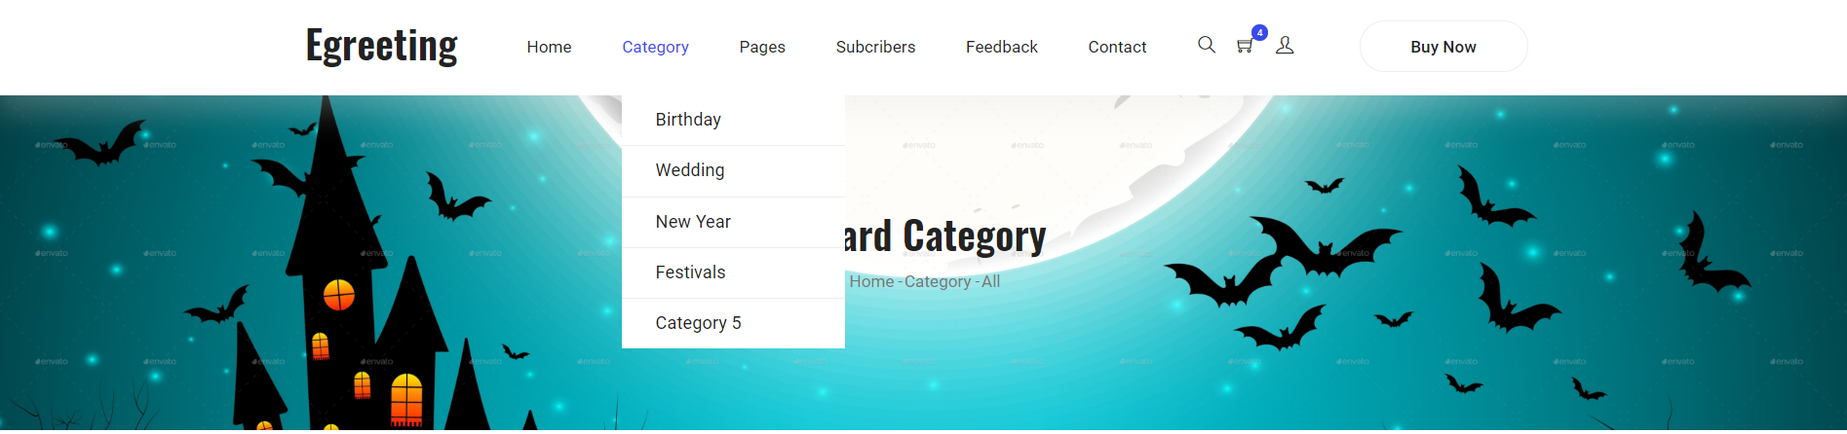

***Figure – 2***

*(Users want to become Subcriber can register by clicking on* ***Subscribers****)*

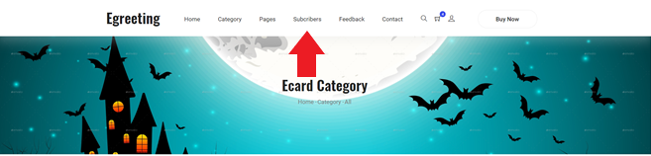

***Figure – 3***

*(Users move to Feedback, Contact page by clicking on* ***Feedback, Contact****)*

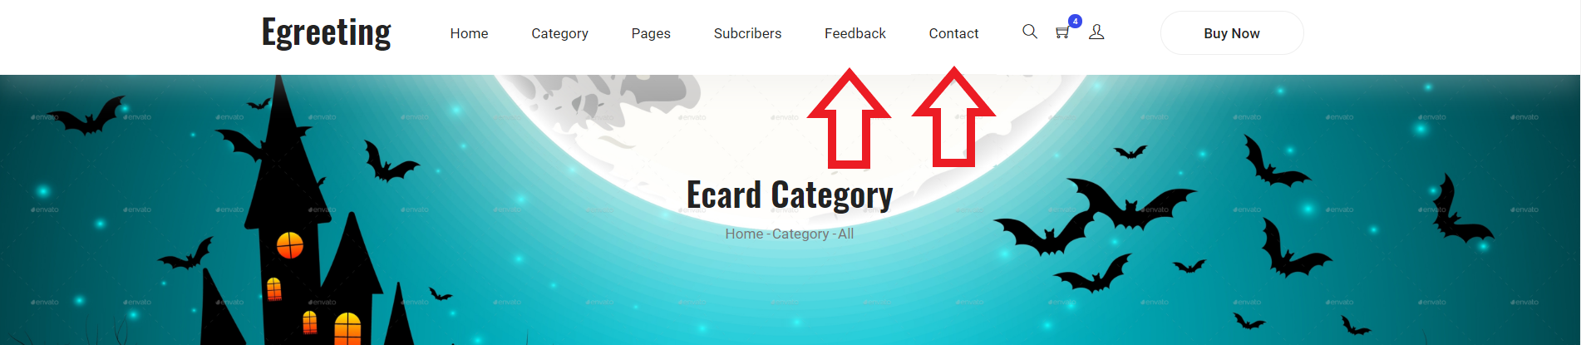

***Figure – 4***

*(Users move to Login page by clicking on* ***the icon below***. *Users the icon color is gray, it mean user have not loged in yet. If user icon color is blue, the user is already logged in)*

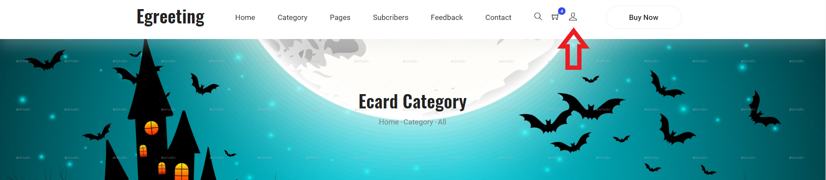

***Figure – 5***

*(Users move to cart page by clicking on* ***the icon below.*** *It display the number of item ecard you have selected. If the number displayed is zero you can’t move to cart page****)***

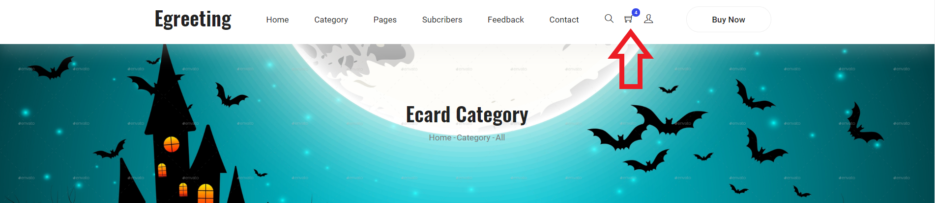

**Footer content:**

This section show slogan of website and firm. From here, users can easily get more quick link to jumb to other pages, information about location, address, email ….

***Figure – 1***

*(Four main part of Footer)*

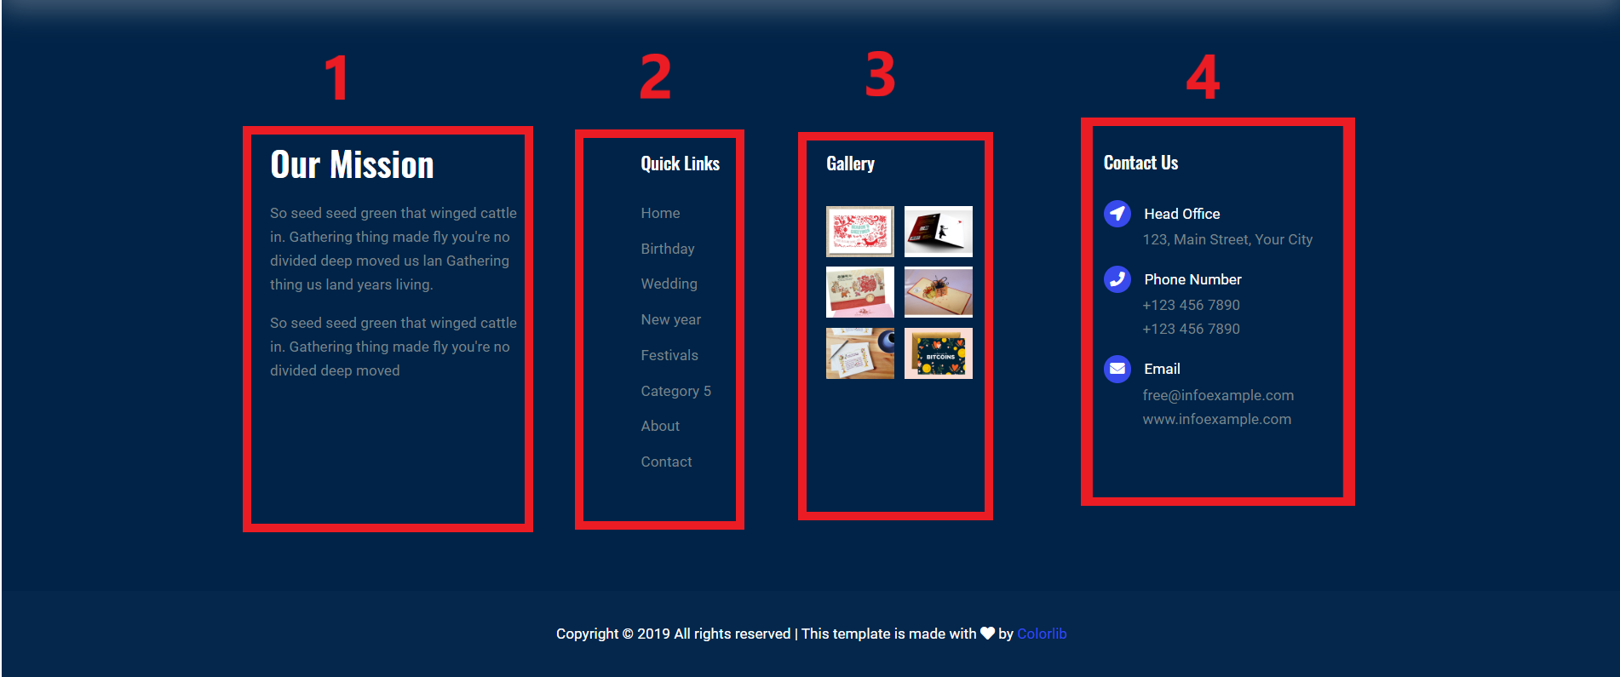

**Main list ecard pages content:**

This section display all ecard or ecard from one category. User can select ecard and add to cart to send

***Figure – 1***

*(Top ecard diplay in top of section)*

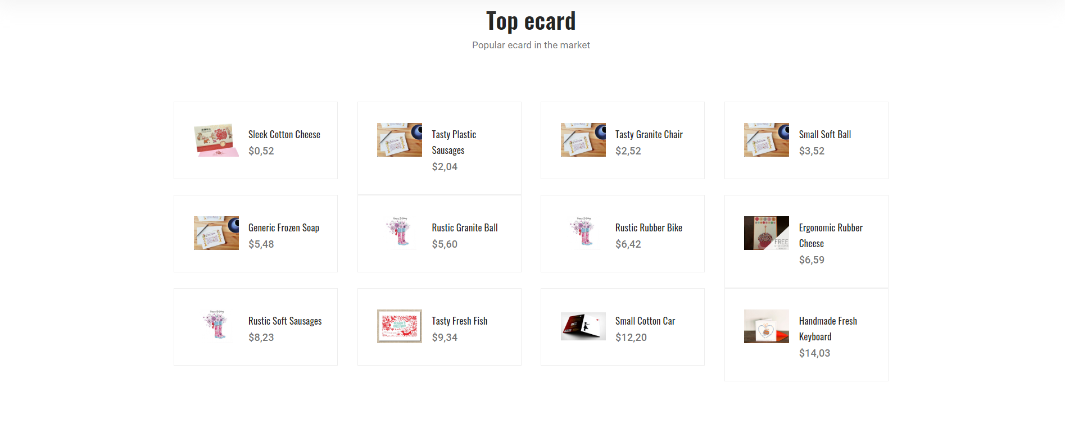

***Figure – 2***

*(The list of items is displayed in one page and is clearly paginated)*

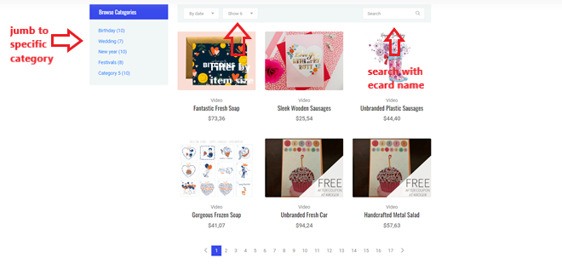

***Figure – 3***

*(When you hover to any ecard, 3 button show. First button is present for action go to detail page, second button clicked, have to change to orange color and number item selected place in header section must be increase 1)*

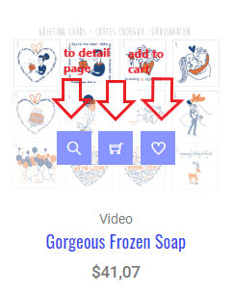 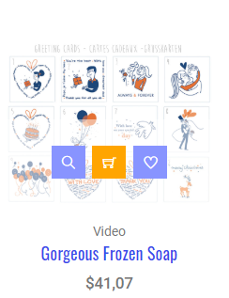

**Ecard detail pages content:**

This section display detail information of ecard. There are thumbnail, ecard file, price, link to category. In addition, user can send feedback for the ecard

***Figure – 1***

*(Show ecard detail)*

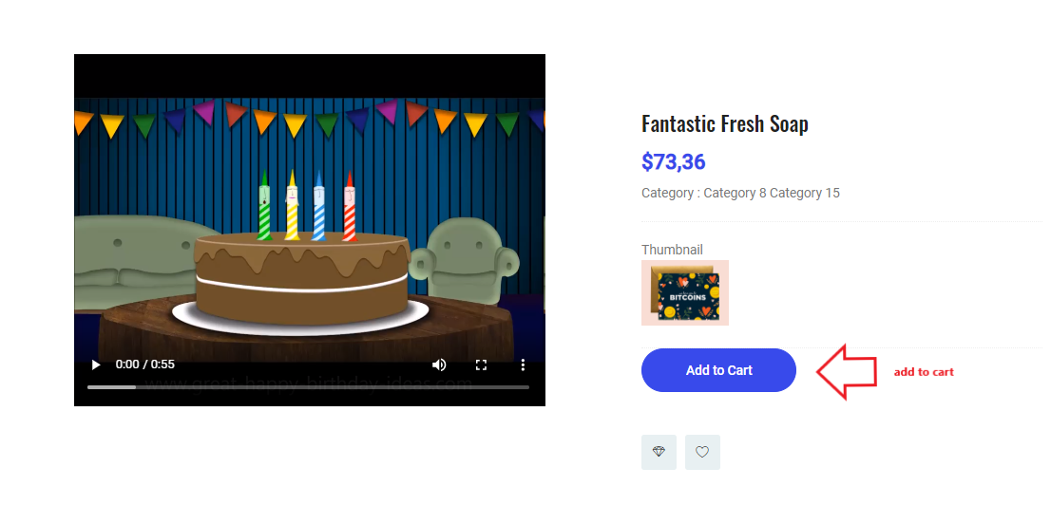

***Figure – 2***

*(Form send feedback)*

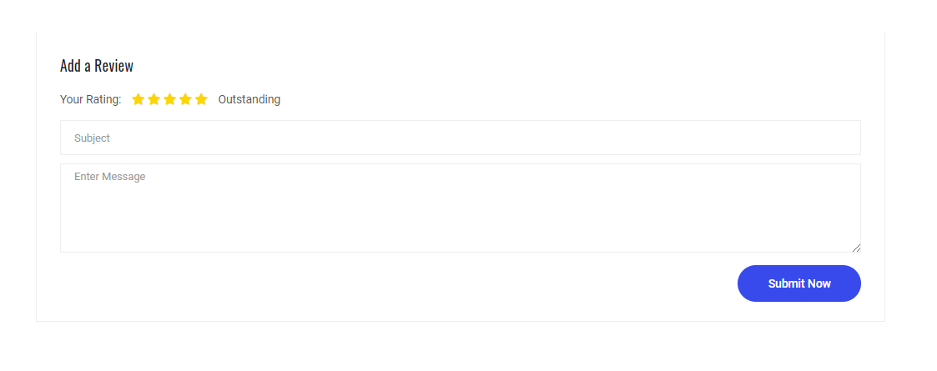

**Cart page content:**

The section display the list of selected items. Users can delete items from the shopping cart or have buttoms to redirect to the item selection page

***Figure – 1***

*(Cart page)*

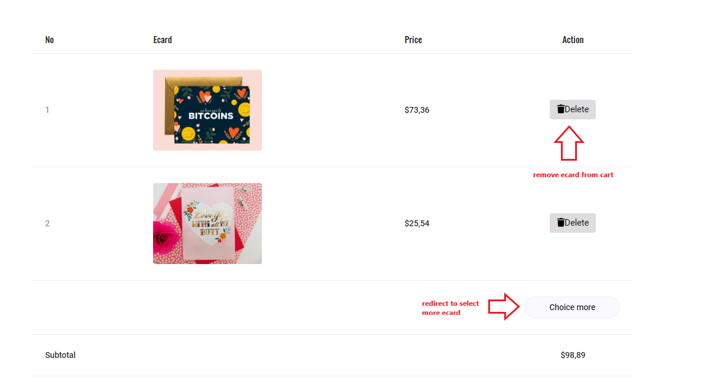

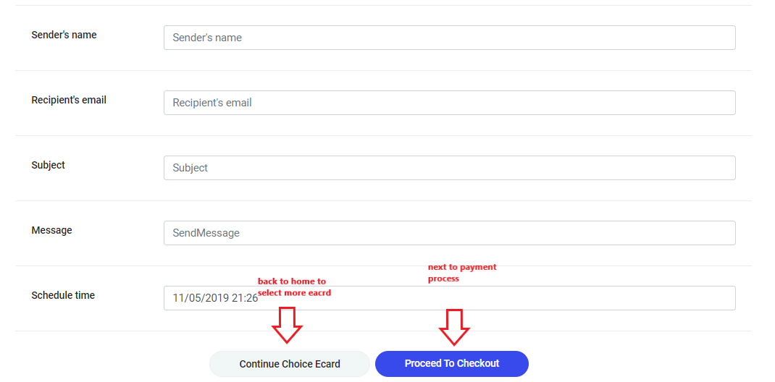

**Payment page content:**

This section display detail information of ecard. There are thumbnail, ecard file, price, link to category. In addition, user can send feedback for the ecard

***Figure – 1***

*(Payment)*

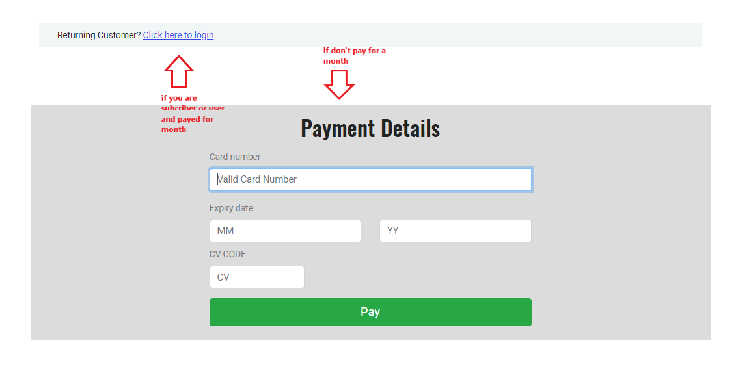

**Login pages content:**

***Figure – 1***

*(User can jubm to login page by clicking the icon or button below)*

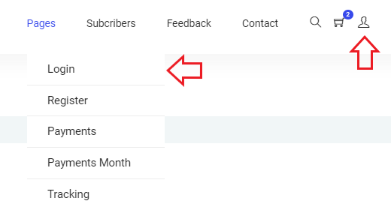

***Figure – 2***

*(Login form)*

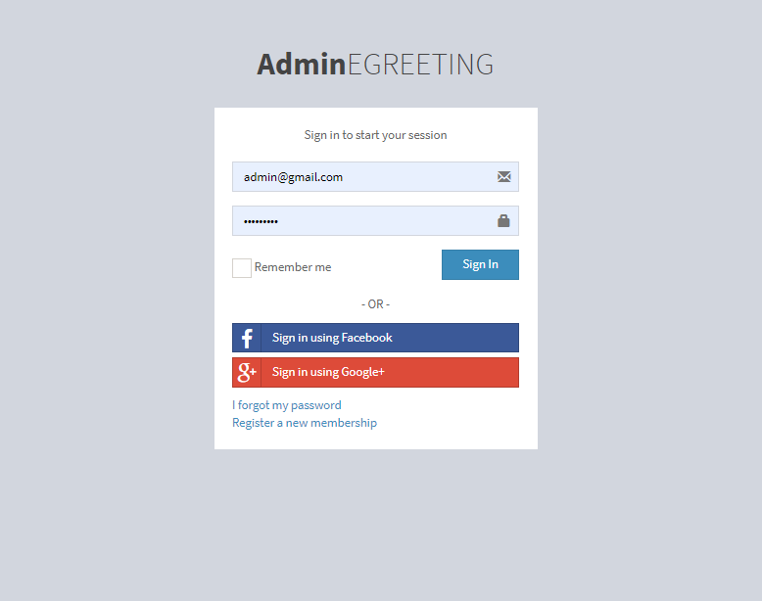

**Register pages content:**

***Figure – 1***

*(User can go to login page by clicking the link header or link in login form)*

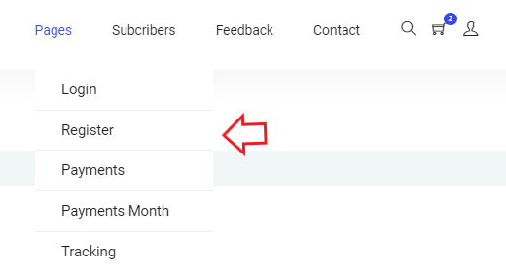 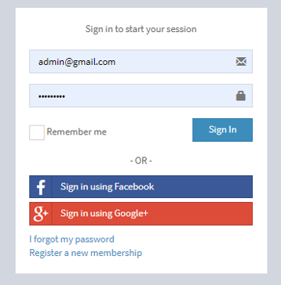

***Figure – 2***

*(User can become member of website by filling all input form and click agree to the terms)*

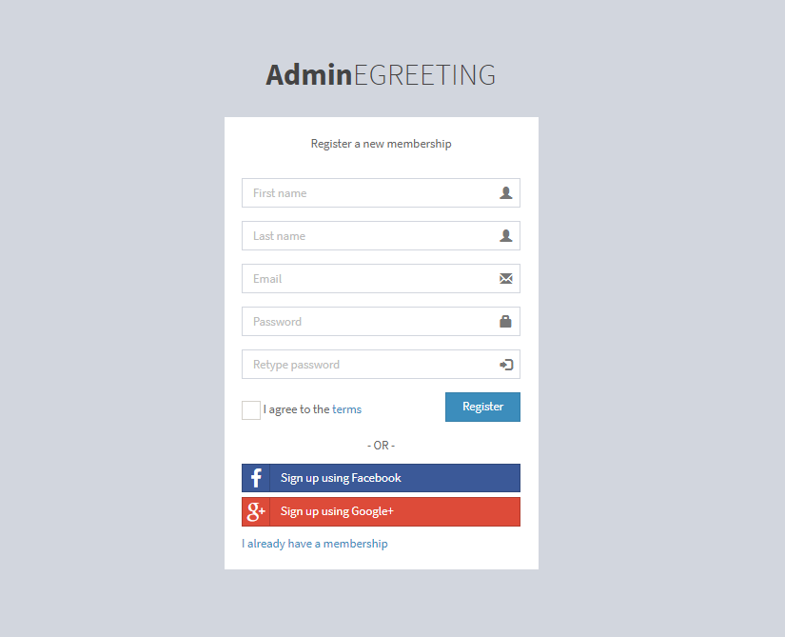

**Index template pages for all area:**

***Figure – 1***

*(Template for all page index of specific area)*

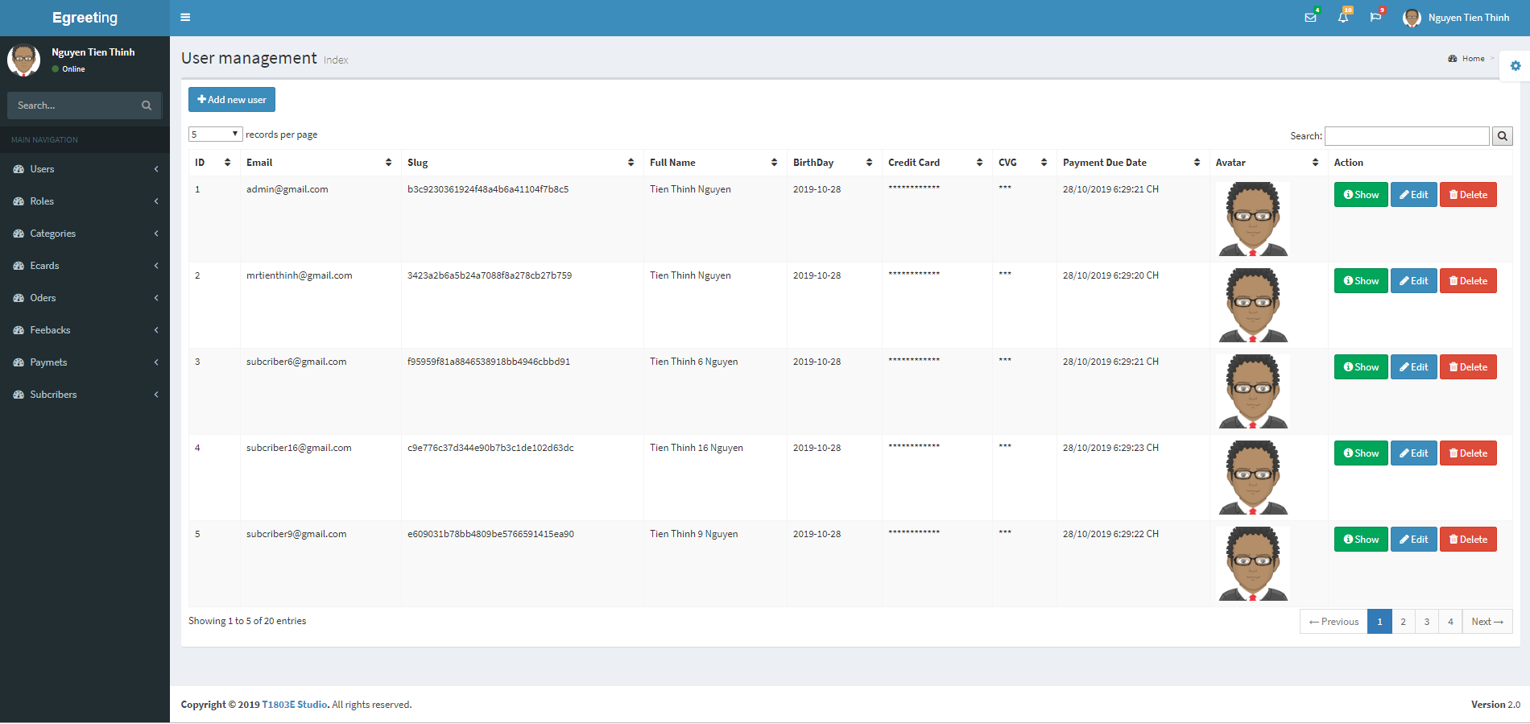

***Figure – 2***

*(Display information of user login, link to logout)*

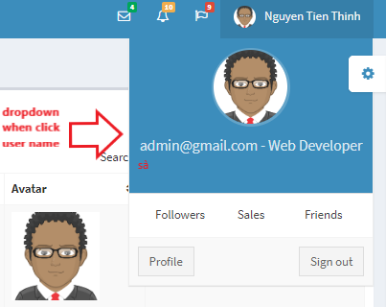

***Figure – 2***

*(Action of sidebar)*

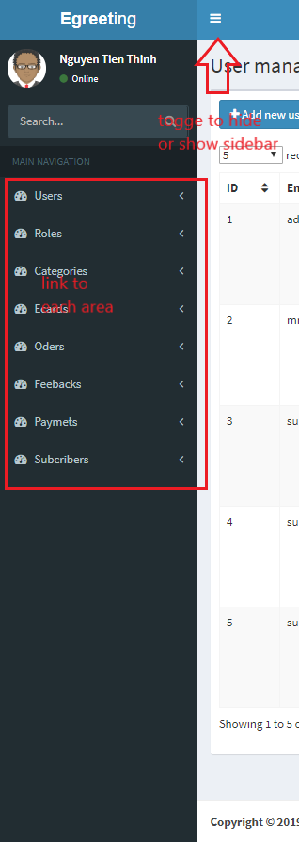

***Figure – 3***

*(Action with data table)*

*Drop downlist to select number of record display each page*



*Search text box*



*Place in bottom left of table, show index number of record show in this page*



*Place in bottom right of table, show link to go to other page with paging content*



***Figure – 4***

*(Action for data)*

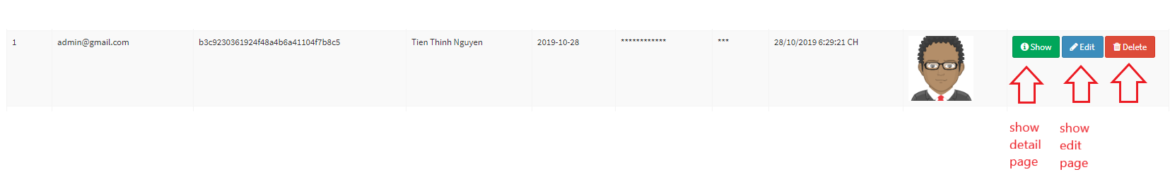

*Confim when you want to delete record*

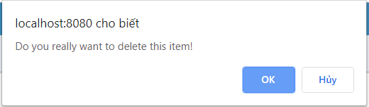

***Figure – 4***

*(Go to the page to create new record by click the button with icon plus)*

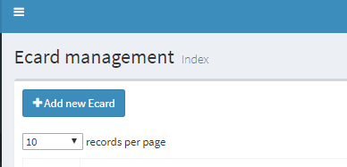

*(Send email of ecard order from user, admin click to button Send all now or click button send in each order or orderdetail)*

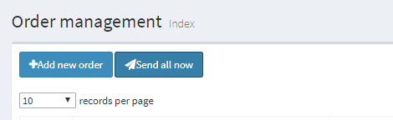





***Figure – 5***

*(Button Sync payment only display in index page of Payment area, when clicking the button, application auto create payment record for this month of all subcribers)*

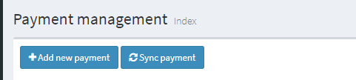

**Create template pages for all area:**

***Figure – 1***

*(Template for all page create of specific area. User must fill all input, checkbox, select list fiel before click submit)*

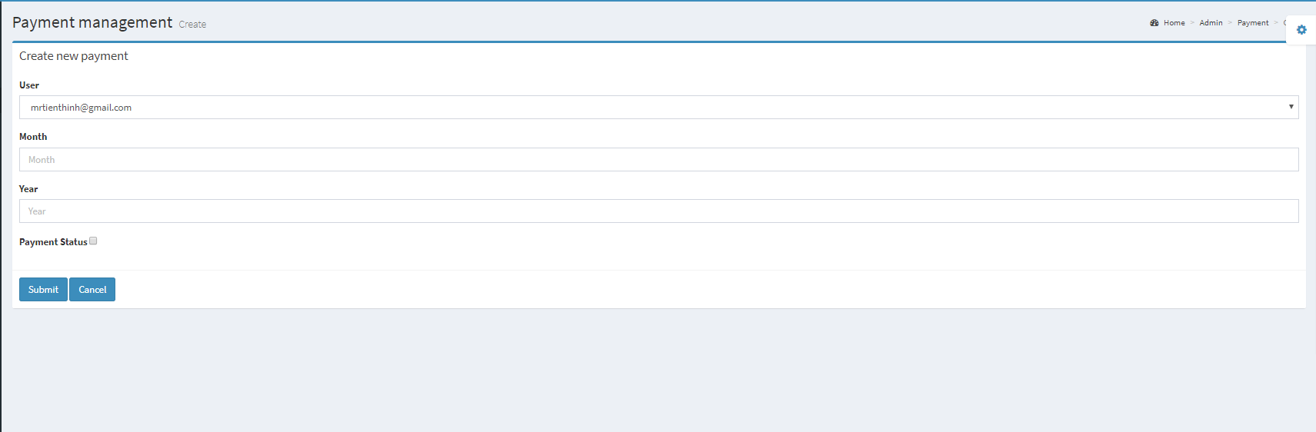

***Figure – 2***

*(Some field of form)*

*Select one from drop down list*

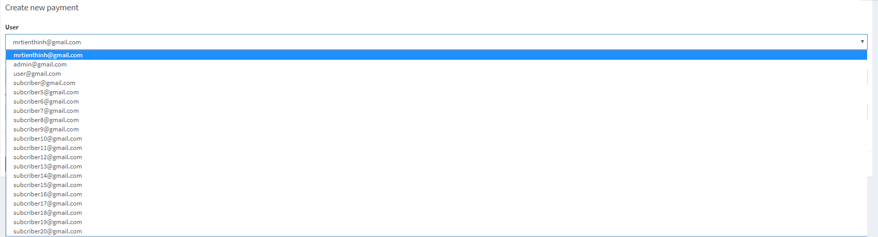

*Select multiple from drop down list****:*** *when admin select one item in dropdownlist, one bagde pressent for the item seleted show. Admin can click to the bagde to remove this item from selected*



*Select file from hardware store data.*



**Create template pages for all area:**

***Figure – 1***

*(Template for all page detail record of specific area. All field must be disabled. User can back by clicking the button Back to Index)*

